PIZZA SALES ESTIMATION

1. Project Background
Plato’s Pizza is a Greek-inspired pizza restaurant located in New Jersey.
The restaurant has been collecting transactional sales data for the past one year, but this data has not been properly analyzed.
Management wants to use data to improve sales, efficiency, and daily operations.
To achieve this, a Business Intelligence (BI) Consultant has been hired to study the data and provide clear insights.
This project focuses on analyzing historical transaction data to understand customer behavior, sales patterns, and operational performance.

2. Problem Statement
Plato’s Pizza has access to a full year of sales data, but the data is not being used for decision-making.
The main problem is the lack of insights into:
- Busy days and peak hours
- Pizza demand during rush periods
- Best and worst selling menu items
- Average value of customer orders
- Seating capacity usage
Without these insights, the restaurant may face:
- Overstaffing or understaffing
- Food waste or shortage
- Missed sales opportunities
- Poor space utilization
The goal of this project is to convert raw sales data into meaningful insights that help the restaurant increase sales and work more efficiently

3. Project Objectives
The main objectives of this project are:
- Identify busiest days and time slots
- Analyze pizza production during peak hours
- Find best-selling and worst-selling pizzas
- Calculate average order value (AOV)
- Measure seating capacity utilization
- Provide actionable recommendations for improvement

4. Data Summary :
The dataset includes 48,620 sales records generated from 21,350 unique orders placed between 1 January 2015 and 31 December 2015. It covers 32 different pizza types, grouped into 4 categories—Classic, Veggie, Supreme, and Chicken—and sold in 5 size variants.
Each record captures key order details such as order date, order time, quantity, unit price, and total price, along with pizza-specific information like name, size, category, and ingredients.
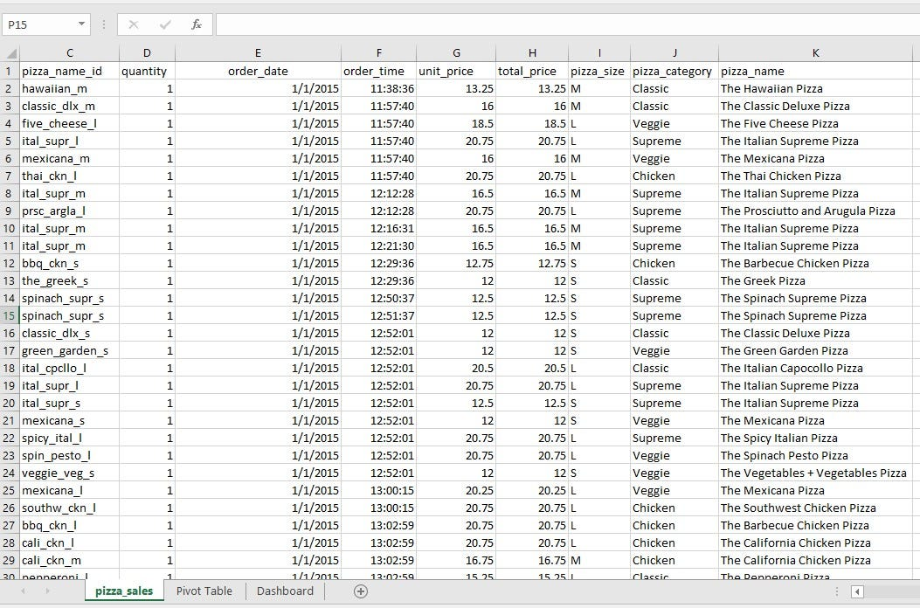

5. EDA [Exploratory Data Analysis]
Exploratory Data Analysis (EDA) was performed on the pizza sales dataset to understand its structure, quality, and readiness for analysis using Microsoft Excel. The dataset contains 48,620 records generated from 21,350 unique orders for the year 2015, where each row represents an individual pizza item sold. The data includes order details, product information, pricing, quantity, category, size, and time-related attributes, providing a complete view of sales activity.
As part of data cleaning, the dataset was first checked for missing values using the ISNULL formula across all columns, and no null or blank values were found, confirming data completeness. Next, duplicate records were examined by applying Conditional Formatting on the order_details_id column to highlight duplicates. After sorting the data based on color-coded cells, no duplicate entries were identified, indicating that each transaction record is unique. Data formats for dates, time, and numeric fields were also reviewed to ensure consistency and correctness.
Overall, the dataset was found to be clean, well-structured, and reliable, with no missing or duplicate values. This confirms that the data is fully prepared for further analysis such as trend analysis, KPI evaluation, and business performance reporting without requiring additional preprocessing.

6.Data Analysis using SQL
-- KPI
-- q.1 What is the total revenue generated in the last year?

select SUM(total_price) as total_revenue from pizza_estimate;

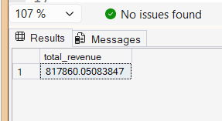

-- q.2 How many total orders were placed?

select COUNT(DISTINCT order_id) as total_orders from pizza_estimate;
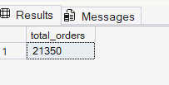

-- q.3 How many total pizzas were sold?

select sum(quantity) as total_pizza_sold from pizza_estimate;

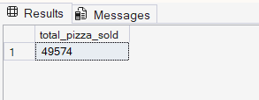
-- q.4 What is the average order value (AOV)? [total revenue / total order ]

select ROUND(SUM(total_price) / COUNT(distinct order_id) , 2) as avg_order_value
from pizza_estimate;
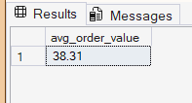
-- q. 5 What is the average number of pizzas per order?

select ROUND(SUM(quantity) / COUNT(distinct order_id) ,2 ) as avg_pizza_pr_order
from pizza_estimate;
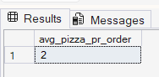

-- q.6 How many pizzas are sold yearly during peak hours?

SELECT
SUM(quantity) as pizza_sold_peak_hours
from pizza_estimate
where
DATEPART(HOUR, order_time) BETWEEN 12 AND 13 -- EFTERNOON TIME
OR DATEPART(HOUR, order_time) BETWEEN 17 AND 18; -- EVENING TIME
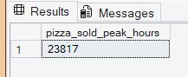

-- q. 7 What is the average number of pizzas sold per hour in day?
WITH hourly_daily_sales AS (
SELECT
order_date,
DATEPART(HOUR, CAST(order_time AS TIME)) AS order_hour, -- here we should find first day avg then we find horu avg
SUM(quantity) AS pizzas_sold
FROM pizza_estimate
GROUP BY
order_date,
DATEPART(HOUR, CAST(order_time AS TIME))
)
SELECT
ROUND(AVG(pizzas_sold * 1.0), 2) AS avg_pizzas_per_hour
FROM hourly_daily_sales;
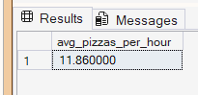

-- q. 8 What is the average revenue per pizza?

SELECT
ROUND(SUM(total_price) / SUM(quantity * 1.0), 2) AS avg_revenue_per_pizza
FROM pizza_estimate;
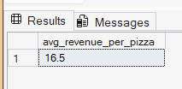

-- Q.9 What is the average revenue generated per day?
WITH daily_sales AS (
SELECT
order_date,
SUM(total_price) AS daily_revenue
FROM pizza_estimate
GROUP BY order_date
)
SELECT
ROUND(AVG(daily_revenue), 2) AS avg_sales_per_day
FROM daily_sales;
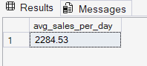

-- CHART

--Q.10 What is the total revenue generated on each day? [line chart]
SELECT
order_date,
SUM(total_price) AS daily_revenue
FROM pizza_estimate
GROUP BY order_date;
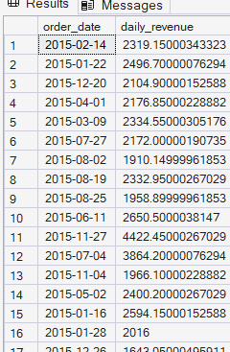

-- q. 11 Which day of the week has the highest number of orders? [column chart]
select * from pizza_estimate;

SELECT
DATENAME(WEEKDAY, order_date) AS day_name,
COUNT(DISTINCT order_id) AS total_orders
FROM pizza_estimate
GROUP BY DATENAME(WEEKDAY, order_date)
ORDER BY total_orders DESC;
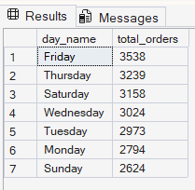

-- q. 12 Which hour of the day is the busiest based on number of orders? [histrogram]

SELECT
DATEPART(HOUR , order_time) as order_hour ,
COUNT(distinct order_id) as total_orders
FROM pizza_estimate
GROUP BY DATEPART(HOUR, order_time)
ORDER BY total_orders desc;
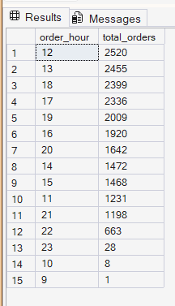
-- q. 13 What is the monthly sales trend across the year? [column chart]

select
DATENAME(MONTH,order_date) as month_name,
SUM(total_price) as total_revenue
FROM pizza_estimate
GROUP BY MONTH(order_date) , DATENAME(MONTH , order_date)
order by total_revenue DESC;
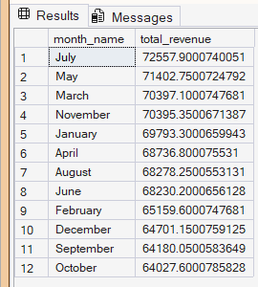

-- q. 14 Which pizzas are the top 5 best-selling by quantity? [pie chart / donut chart]

SELECT TOP 5
pizza_name,
SUM(quantity) AS total_quantity_sold
FROM pizza_estimate
GROUP BY pizza_name
ORDER BY total_quantity_sold DESC;

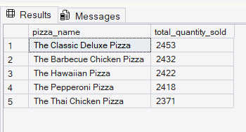
-- q. 15 Which pizzas are the bottom 5 worst-selling by quantity? [pie / donut chart]

SELECT TOP 5
pizza_name,
SUM(quantity) AS total_quantity_sold
FROM pizza_estimate
GROUP BY pizza_name
ORDER BY total_quantity_sold ASC;

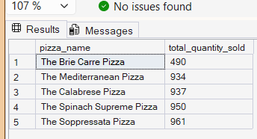
-- q. 16 Which pizzas generate the highest revenue? [tree map]

SELECT TOP(3)
pizza_name,
SUM(total_price) AS total_revenue
FROM pizza_estimate
GROUP BY pizza_name
ORDER BY total_revenue DESC;
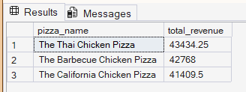

-- q. 17 Which pizza categories contribute the most to total sales with percentage? [funnal chart ]

SELECT
pizza_category,
SUM(total_price) AS total_revenue,
ROUND(
SUM(total_price) * 100.0 / SUM(SUM(total_price)) OVER (),
2
) AS revenue_percentage
FROM pizza_estimate
GROUP BY pizza_category
ORDER BY total_revenue DESC;
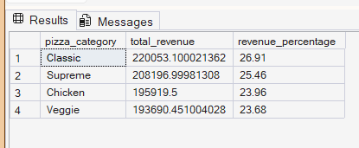

-- q.18 Are customers ordering more small or large pizzas? [funnal chart ]

SELECT
pizza_size,
SUM(quantity) AS total_pizzas_sold,
CAST(
ROUND(
SUM(quantity) * 100.0 / SUM(SUM(quantity)) OVER (),
2
) AS DECIMAL(5,2)
) AS percentage_share
FROM pizza_estimate
GROUP BY pizza_size
ORDER BY total_pizzas_sold DESC;
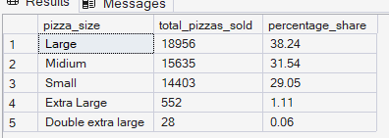

7.Dashboard in POWER BI
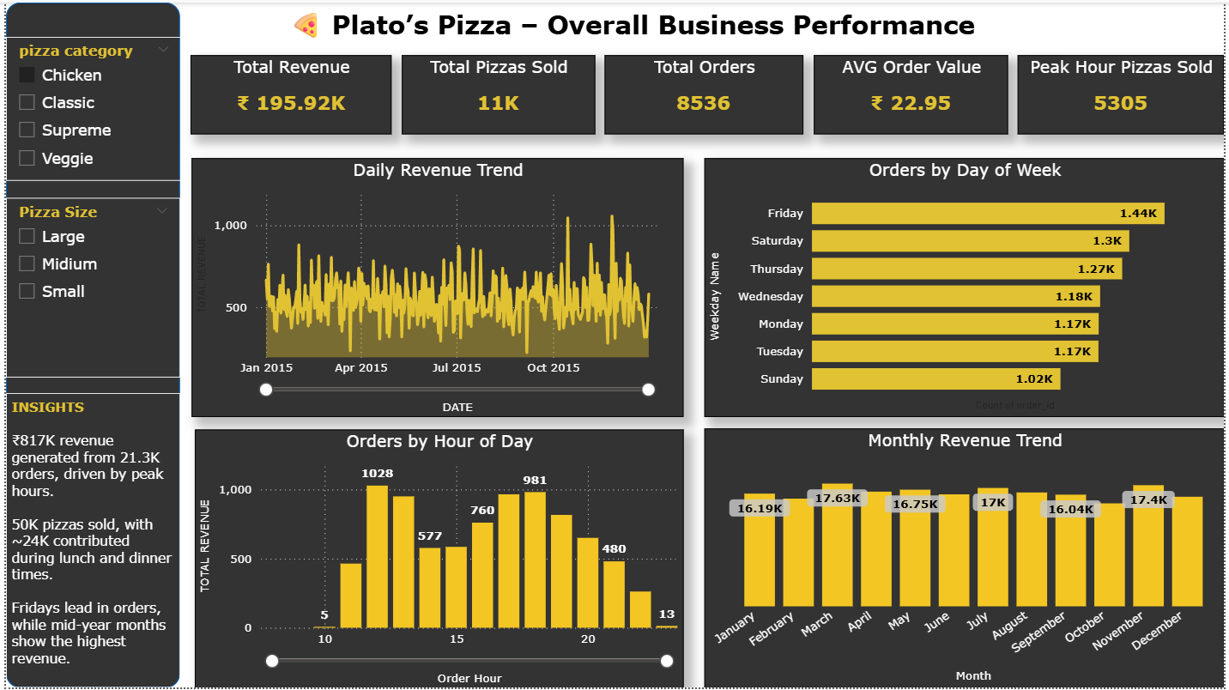
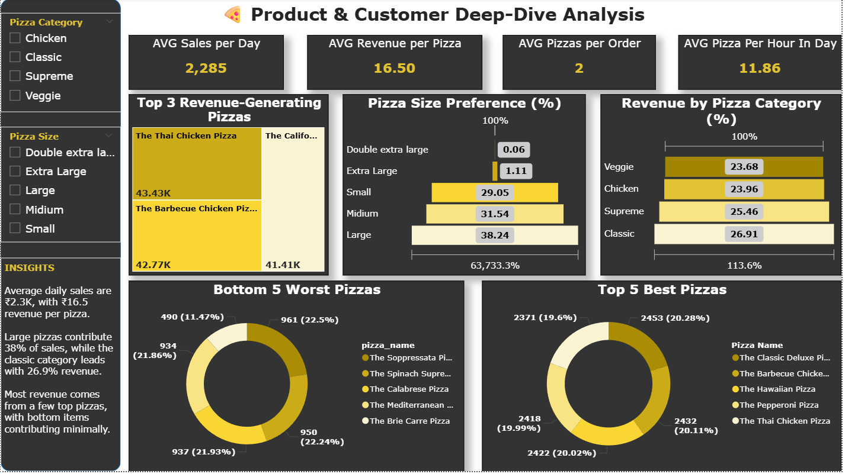

8.Busienss Recommendation
- Optimize Staffing During Peak Hours:
Add more staff during lunch (12–13 hrs) and evening (17–18 hrs) busy times to serve customers faster and avoid delays, without increasing staff during slow hours.
- Focus on High-Performing Pizza Categories:
Give more attention to pizza categories that earn the most revenue by placing them clearly on the menu and planning stock around them.
- Promote Best-Selling Pizzas and Review Low Performers:
Promote pizzas that sell the most and review low-selling pizzas to improve them or remove them to reduce waste.
- Increase Average Order Value Through Bundling:
Offer combo meals, extra toppings, and size upgrades to encourage customers to spend more per order.
- Align Inventory With Demand Trends:
Plan ingredients based on busy and slow periods to avoid running out of stock or wasting food.
- Leverage Popular Pizza Sizes for Growth:
Promote popular pizza sizes with special offers and pricing to increase total sales.

